1. Table should not be expanded when page loads
2. Submit button to be disabled and Grayed out 🡪 Completed

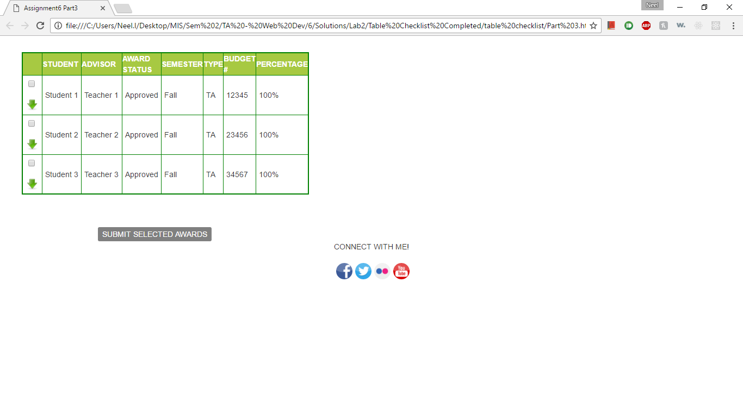

1. On selecting any of the check-boxes, background color to be changed for the particular row and Submit button to turn Orange.
2. Deselecting the check box will make the row white again. Also, if none of the rows are selected, the Submit button should be Grayed out again(disabled). (i.e., if 1 or more of the check-boxes are selected, the Submit button will be enabled and background color will be orange. If none are selected, it will be disabled and background set to Gray)

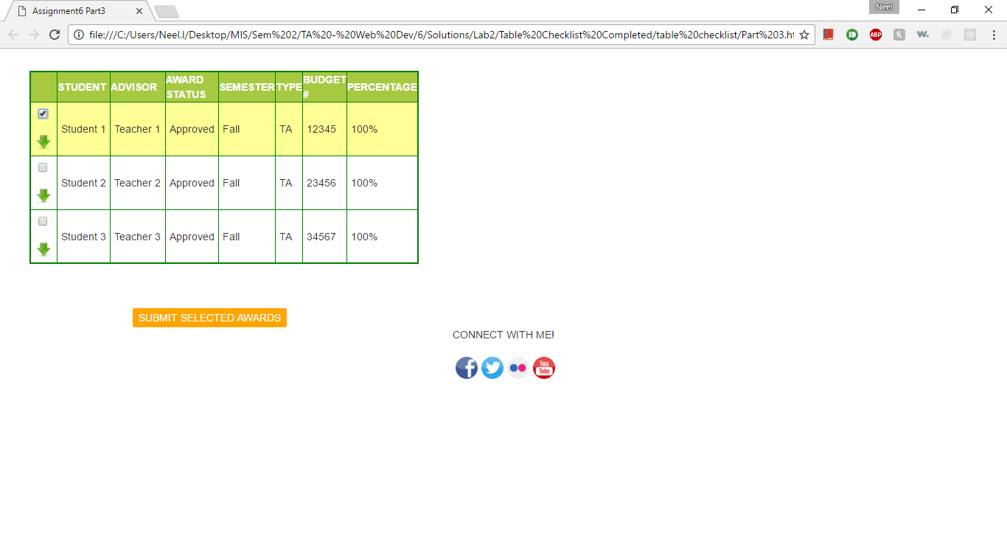

1. Clicking on any of the green arrows will expand the particular row. Clicking it again will collapse it (i.e., toggle view on click)

